(a) Create a package: learning_service

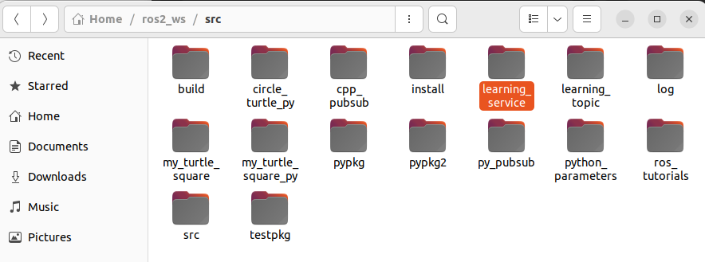

(b) build service file (Person.srv)

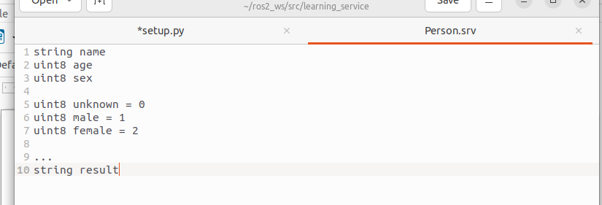

(c) Add Dependencies in package.xml

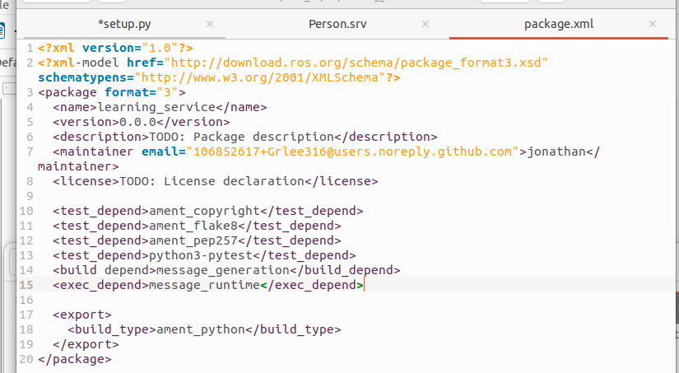

(d) Add compile options in setup.py

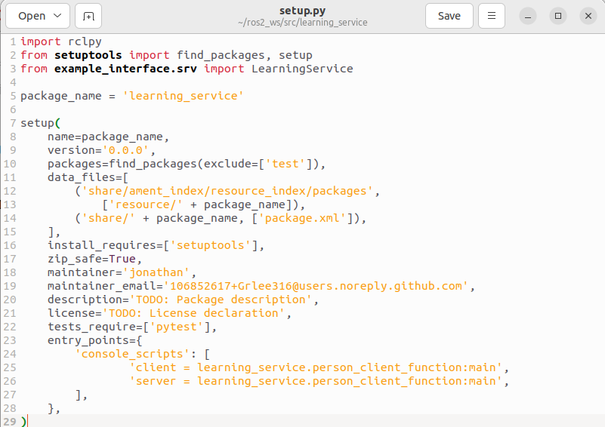

(e) catkin_make Compile

in ROS2, it will be colcon make

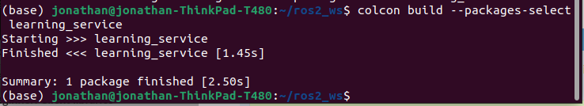

(f) Create the Service Client Node Code in Python

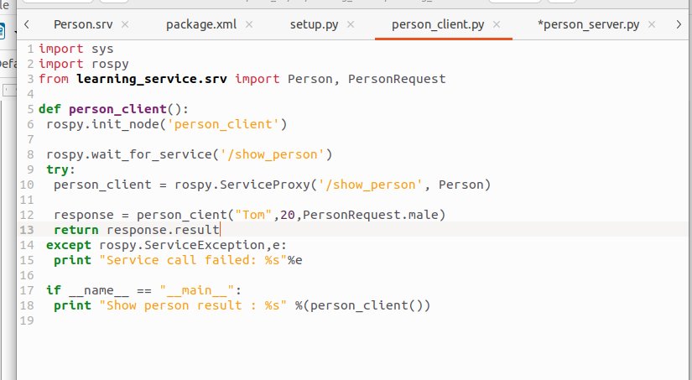

(g) Create the Service Server Node Code in Python

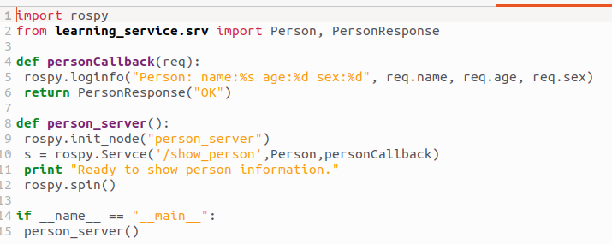

(h) Compiling code

(I) Server and Client Compile

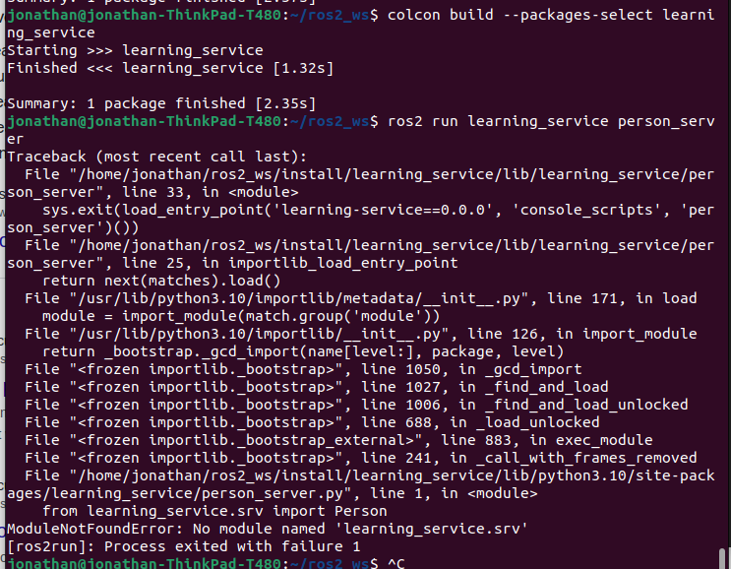

I was able to build the code, but could not run the program because it still have a problem with finding the module. Same thing happening with the Person_client as well. I also tried to make this in c++, but the problem changed, and I still unable to compile with c++.

